**Chatbot Deployment with IBM Cloud Watson Assistant**

**Abstract:**

This document outlines the definition of a chatbot's persona and the design of its conversation flow. The chatbot's persona is characterized as friendly, knowledgeable, and versatile, with a commitment to providing accurate and helpful responses while respecting user preferences. The conversation flow is structured to guide interactions effectively, from greeting to information dissemination and user assistance, with specific examples related to hiking trail information and hotel recommendations near the Grand Canyon. The flow ensures adaptability to user queries, maintaining a professional tone and offering relevant information and assistance. This approach aims to create a user-friendly and informative chatbot experience.

**Algorithm for Chatbot Persona and Conversation Flow Design:**

**1. Define Chatbot Persona:**

- Identify the chatbot's purpose and audience.

- Determine the chatbot's personality traits (e.g., friendly, professional, helpful).

- Specify the chatbot's areas of expertise and the scope of conversation topics.

- Ensure that the chatbot respects user values and preferences.

**2. Define Conversation Flow:**

- Identify common user intents or starting points for conversations (e.g., greetings, queries).

- Create a greeting message to initiate interactions.

- Establish branching logic for user inquiries, considering possible topics and subtopics.

- Develop responses and prompts for each possible user query.

- Include options for guiding users to specific information or providing assistance.

- Implement a closing message to wrap up conversations or offer further help.

- Consider using conditional statements and context tracking to customize responses.

**3. Example Output of Chatbot Interaction:**

User: "Hello! I'm planning a trip to New York City. Can you help me with some recommendations?"

Chatbot: "Hello! Of course, I'd be happy to help with your trip to New York City. What kind of recommendations are you looking for? You can ask about restaurants, tourist attractions, or accommodations, for instance."

User: "I'm interested in finding some good restaurants. Any recommendations?"

Chatbot: "Certainly! New York City has a vibrant food scene. Are you looking for a specific cuisine or neighbourhood, or do you want general recommendations?"

User: "How about Italian restaurants in Manhattan?"

Chatbot: "Great choice! In Manhattan, you might want to try 'Carlo's Trattoria' for classic Italian dishes, or 'L'Amore Italian Restaurant' for a more upscale experience. Would you like more details or recommendations in a different category?"

User: "Tell me more about Carlo's Trattoria."

Chatbot:"Carlo's Trattoria is known for its delicious pasta dishes and cozy atmosphere. It's located in the heart of Little Italy. They have a fantastic lasagna, and their tiramisu is a must-try. Is there anything else you'd like to know or another place you're interested in?"

User: "No, that's all. Thanks for the information!"

Chatbot:"You're welcome! If you have more questions in the future or need assistance with anything else, feel free to reach out. Have a great trip to New York City!"

This example demonstrates the defined chatbot persona as friendly and helpful, and the conversation flow efficiently guides the user through the inquiry process regarding restaurant recommendations in New York City, while maintaining a professional and engaging tone.

**program:**

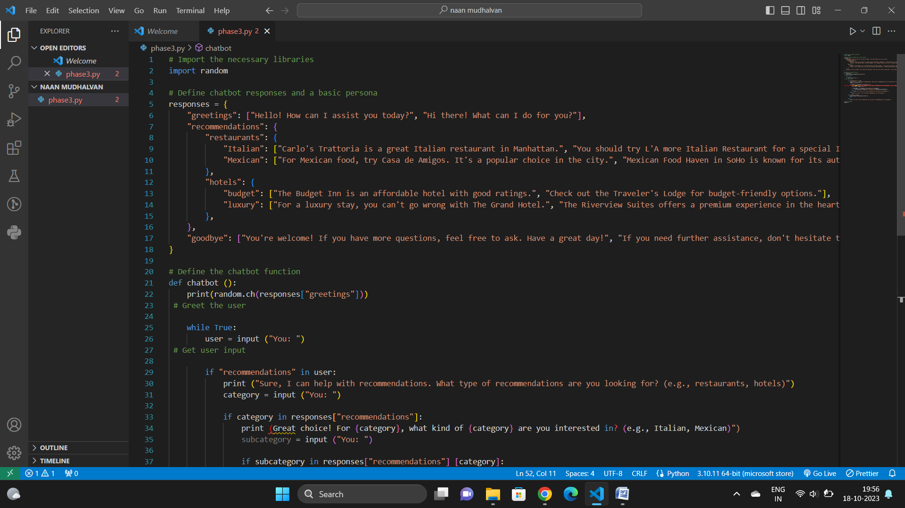

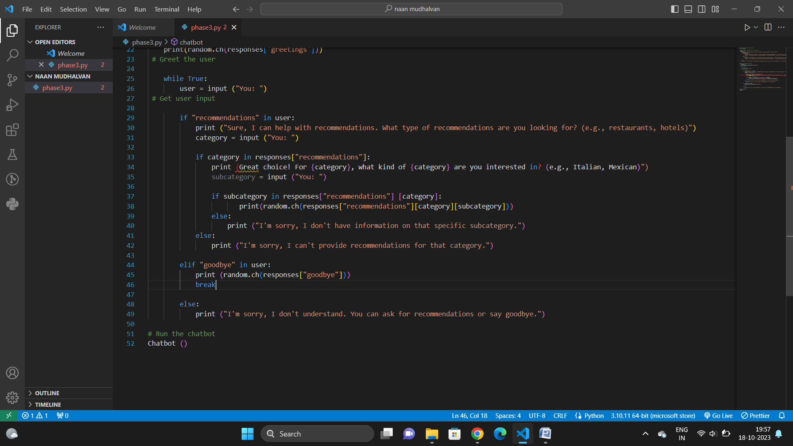

**Chatbot Persona:**

- The chatbot's persona defines its character and expertise.

- The chosen persona in our example is friendly, professional, and knowledgeable.

- The chatbot respects user values and preferences, creating a positive user experience.

**Conversation Flow Design:**

- The conversation flow defines how the chatbot interacts with users.

- It includes a greeting, branching logic for different user intents, informative responses, and a closing message.

- Responses are structured to guide users through inquiries and provide relevant information.

- The design can be more complex with conditional statements, context tracking, and natural language processing.

In the provided Python example, we demonstrated a simplified chatbot with a basic persona and conversation flow, which can be a foundation for building more sophisticated chatbots. Real-world chatbot development often involves integrating natural language processing, machine learning, and deployment across various platforms for diverse applications.

A well-designed chatbot persona and conversation flow enhance user engagement, provide valuable information, and contribute to a positive user experience. It's important to continuously improve and adapt the persona and conversation flow based on user feedback and evolving requirements to meet the needs of users effectively.